Cynthia Cho
Assignment 3
Due Date: October 31, 2017

- Use Python SQL to complete the below.
Books(ISBN, Name, Price, NumberOfCopies)

- Identify a primary key generate and execute a python SQL DDL command to Create table.
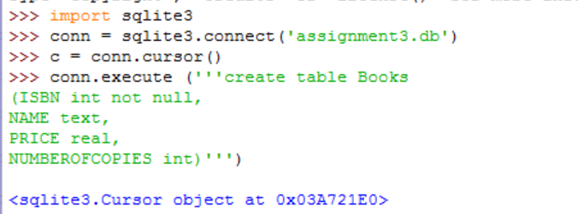

- Make your own data and insert 10 rows in the table created using python SQLite.

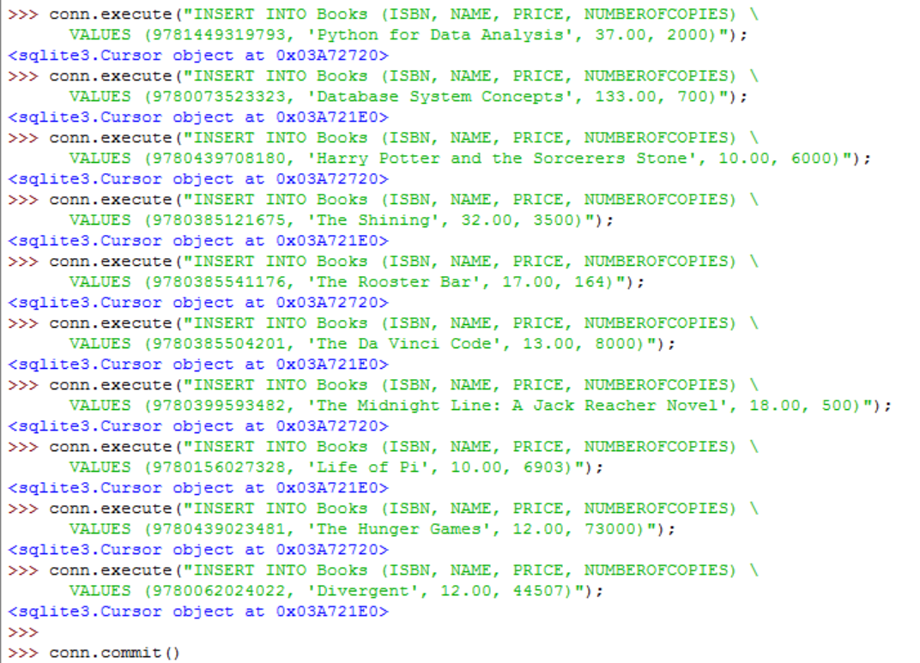

- Retrieve all the records from the table Books.
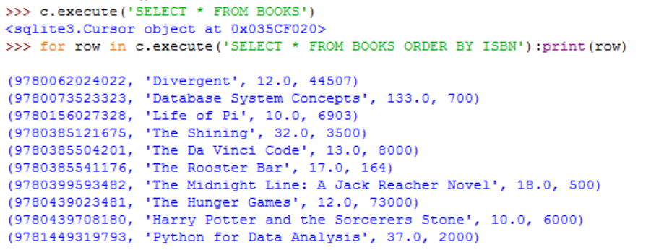

- Insert another record in the table as ('9875465248','Programming With Python',100,50)

- Update the record inserted above – Price -> new Value -> 60 and Number of copies -> new value -> 100

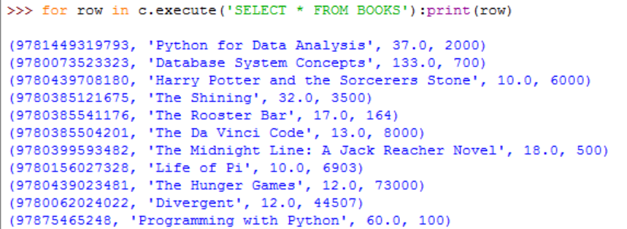

- Delete the record from the above table where number of copies = 100

Delete the last added record since it is the only record with 100 number of copies.

- Retrieve all the records again from the Books table.

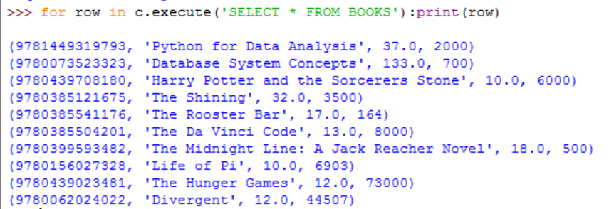

- Retrieve sum of all copies and the avg price from the above table.

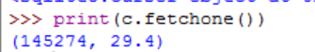

- Create the below tables using SQL.
- Create the Person table. Person(person_id,first_name,last_name)
Primary Key: person_id; All the other fields are required.

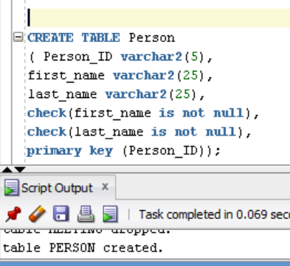

- Create the Building table. Building (building_id,building_name)
Primary Key: building_id; All the other fields are required.
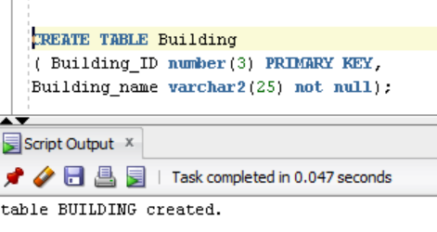
- Create the Room table. Room(room_id, room_number, building_id, capacity)
Primary Key: room_id; All the other fields are required.

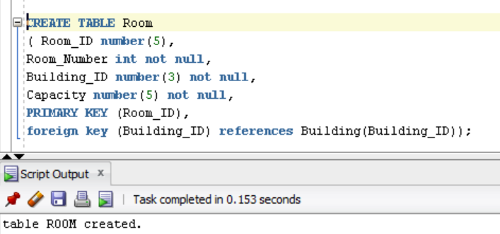

- Create the Meeting table. Meeting (meeting_id,room_id,meeting_start,meeting_end)
Primary Key: meeting_id; ; All the other fields are required.

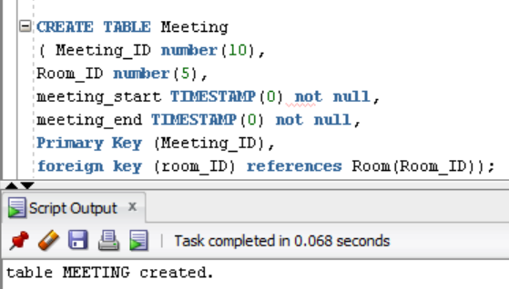

- Create the Person-Meeting intersection table. Person_meeting(person_id,meeting_id)
Primary Key: person_id, meeting_id

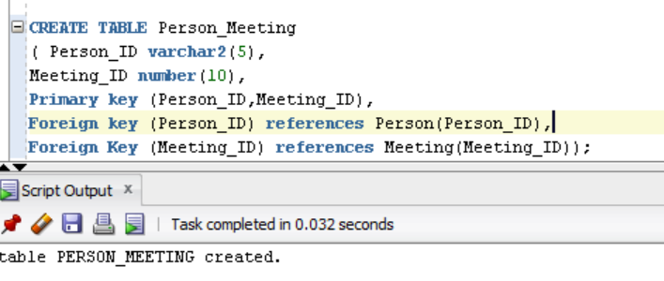

- Insert the below data in the Person table
(Tom, Hanks)
(Anne", Hathaway)
(Tom, Cruise)
(Meryl", Streep)
(Chris, Pratt)
(Halle, Berry)
(Robert, De Niro)
(Julia, "Roberts")
(Denzel, "Washington)
(Melissa, McCarthy)

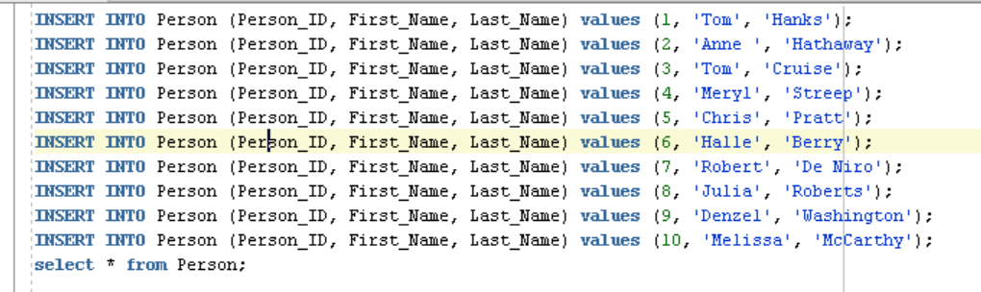

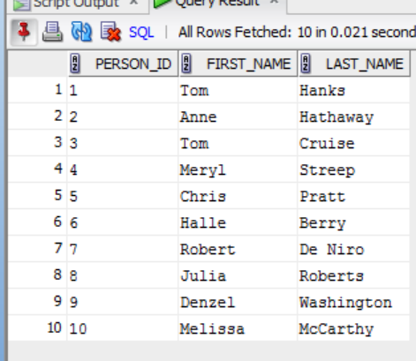

- Insert the below data in the Building table
(Headquarters)
(Main Street Building)

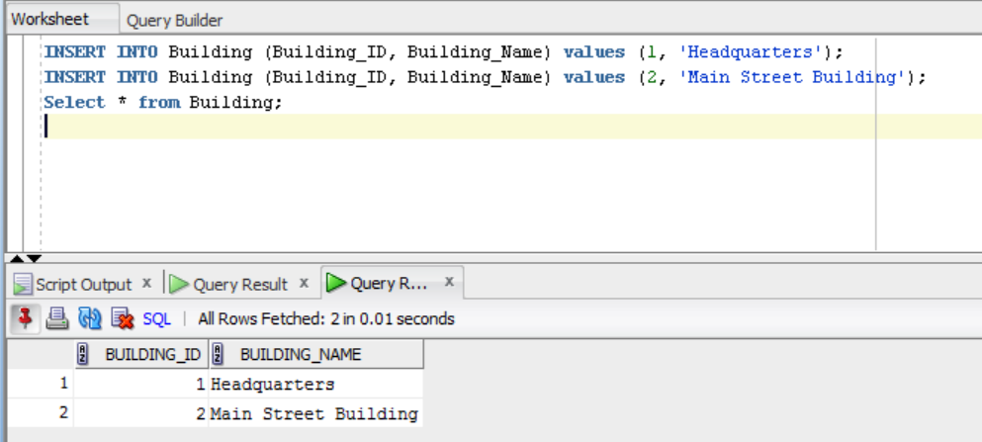

- Insert the below data in the Room table
(room_number, building_id, capacity)
(100, 1, 5)
(200, 1, 4)
(300, 1, 10)
(10, 2, 4)
(20, 2, 4)

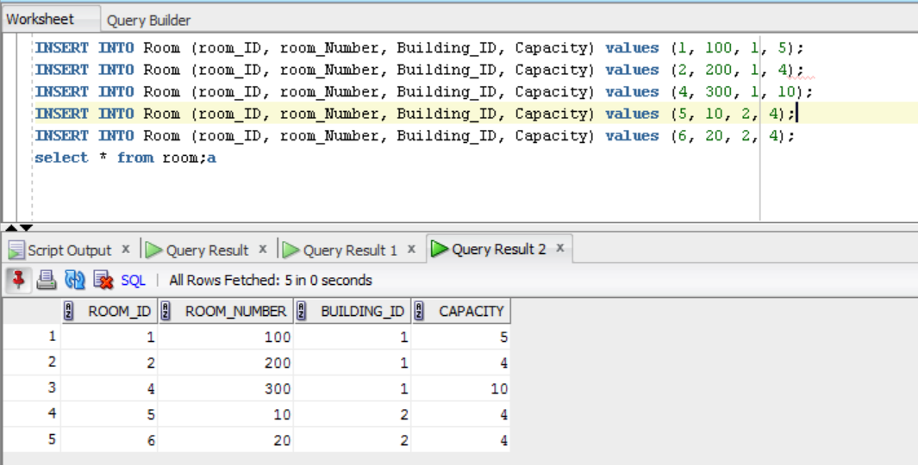

- Insert the below data in meeting table
meeting (room_id, meeting_start, meeting_end)
(1, 2016-12-25 09:00:00, 2016-12-25 10:00:00)
(1, 2016-12-25 10:00:00, 2016-12-25 12:00:00)
(1, 2016-12-25 11:00:00, 2016-12-25 12:00:00)
(2, 2016-12-25 09:00:00, 2016-12-25 10:00:00)
(4, 2016-12-25 09:00:00, 2016-12-25 10:00:00)
(5, 2016-12-25 14:00:00, 2016-12-25 16:00:00)

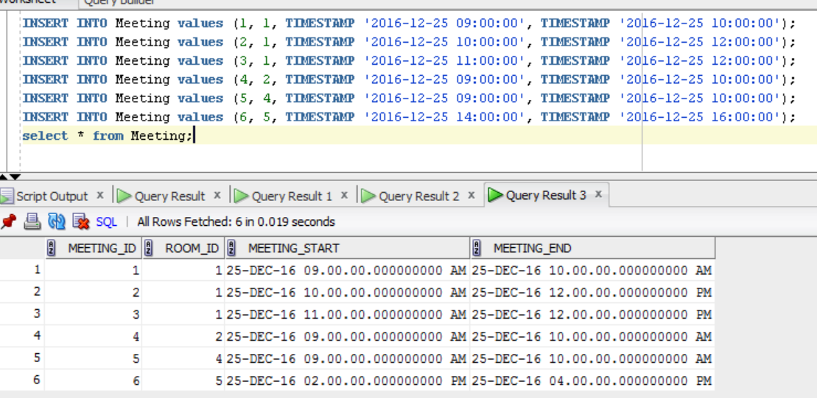

- Insert the below data in person_meeting table
person_meeting (person_id, meeting_id)
(1, 1)
(10, 1)
(1, 2)
(2, 2)
(3, 2)
(4, 2)
(5, 2)
(6, 2)
(7, 2)
(8, 2)
(9, 3)
(10, 3)
(1, 4)
(2, 4)
(8, 5)
(9, 5)
(1, 6)
(2, 6)
(3, 6)

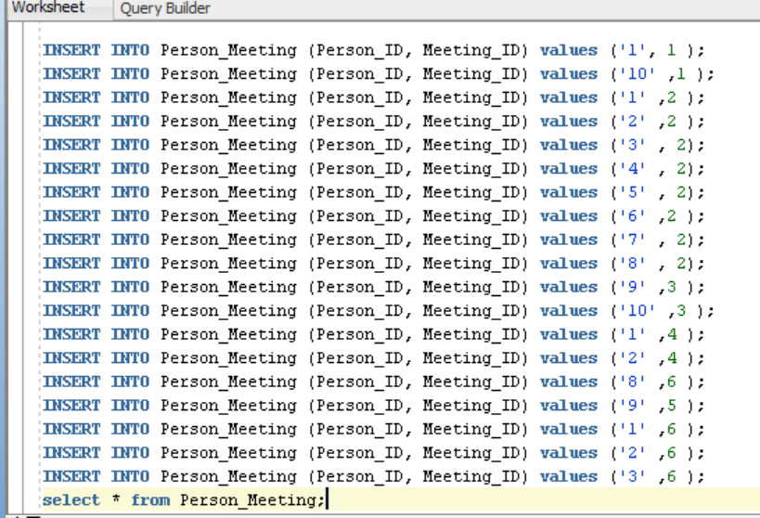

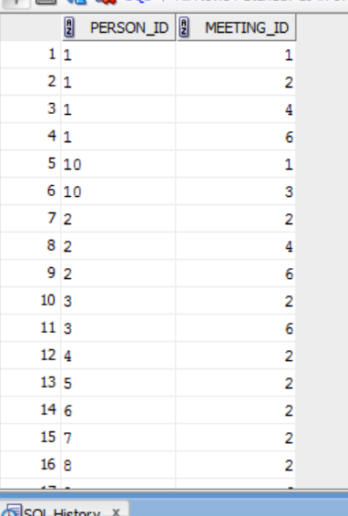

- Find all the meetings that Tom Hanks has to attend:
Tom has to attend Meeting 4 meetings: Meeting_ID: 1, 2, 4, and 6

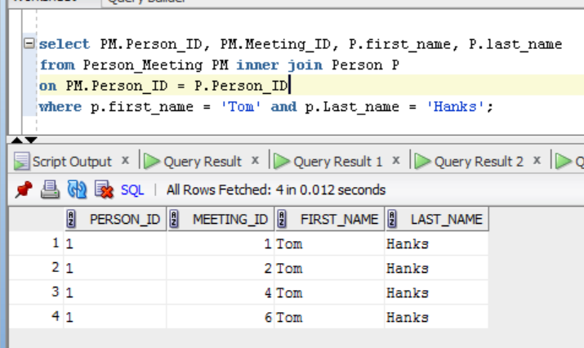

- Find all the people that are attending meeting ID 2:
All the people listed below have Meeting_ID ‘2.’ Total number of people: 8.
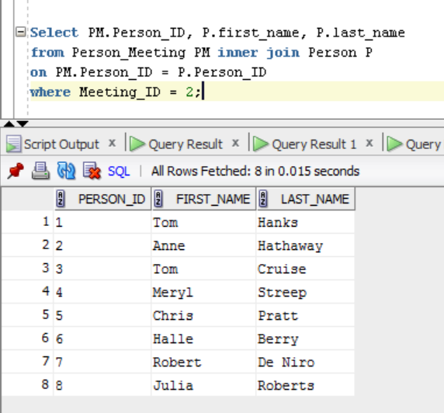

- Find all the people who have meetings in the Main Street building:

The four people listed below have meeting in the Main Street building.
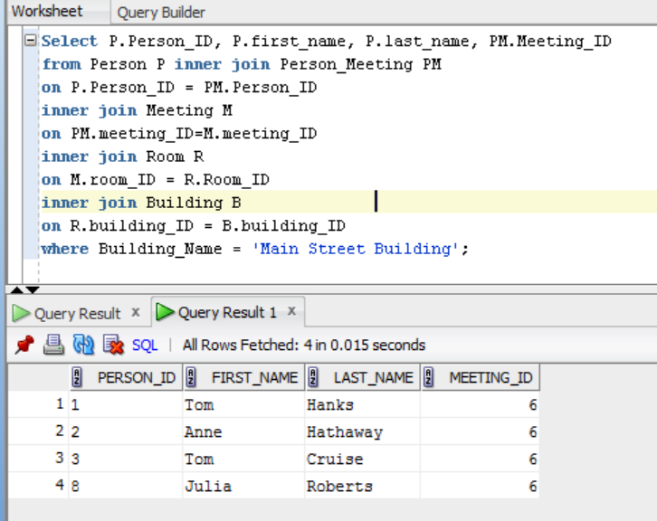

- Find the number of attendees for every meeting:

The below query result shows the number of people in each meeting.

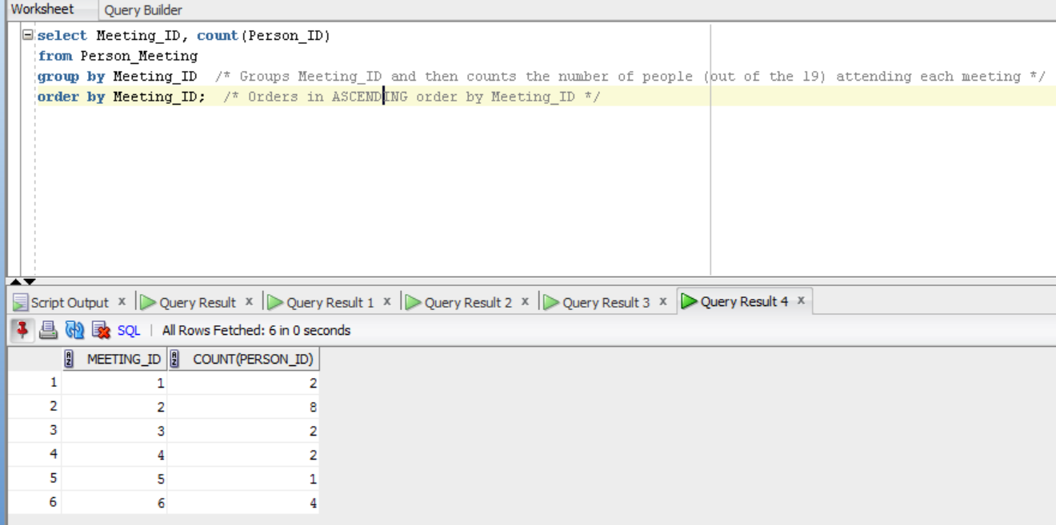

- Find All of the People that Have Meetings Only Before Dec. 25, 2016 at Noon Using INNER JOINs:

Below shows the number of people who have meetings on Dec. 25, 2016, that starts and ends before 12pm. What I did here was make it so that it was not inclusive of 12pm so that the meetings start and end before 12pm.

